**Bulldog Bell Schedule**

**Howard School *2023*-** ***2024***

|  |  |
| --- | --- |
| **Morning** |  |
| 7:45AM  7:55AM  8:00AM  **Recess** | Teacher Duty (Day Begins)  Warning Bell  School Day Begins/Announcements |
| 9:15AM-9:30AM  9:30AM-9:45AM  9:50AM-10:05AM  10:05AM-10:20AM  **Lunch** | TK  K, 1, 2, 3  4, 5, 6  7, 8 |
| 11:00AM-11:45PM  11:25PM-12:10PM  11:50-12:35  12:15-1:05  2:45PM  3:15PM | TK  K, 1, 2, 3  4, 5, 6  7, 8  Dismissal  Teacher Duty Day Ends |

After 8:05AM = Tardy

After 8:30AM = Tardy more than 30 minutes

**Bulldog Bell Schedule**

**2023-2024**

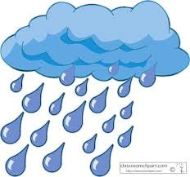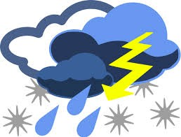 **Howard Inclement**

**Weather Lunch Schedule**

11:00AM-11:30AM TK

11:35AM-12:05PM K-3

12:10PM-12:40PM 4-6

# 12:45PM-1:15PM 7-8

# *Teachers, please pick up your classes from the cafeteria after your 30-minute lunch.*